Course INT 428

Name | Alok Kumar Mahato | Roshan Kumar
Roll no- | 19 | 64
Registration no- | 12325978 | 1232274



INVENTION DISCLOSURE FORM

Details of Invention for better understanding:

1. TITLE: AI-Powered Adaptive Typing Tutor.

2. INTERNAL INVENTOR(S)/ STUDENT(S): All fields in this column are mandatory to be filled
A. Full name | Roshan Kumar
Mobile Number | 7352203126
Email (personal) | shahroshan@gmail.com
UID/Registration number | 12322743
Address of Internal Inventors | Lovely Professional University, Punjab-144411, India
Signature (Mandatory) | 

B. Full name | _{Alok Kumar Mahato}
Mobile Number | 7029248522
Email (personal) | Alokkumarmahato2673212@gmail.com
UID/Registration number | 12325978
Address of Internal Inventors | Lovely Professional University, Punjab-144411, India
Signature (Mandatory) | 

EXTERNAL INVENTOR(S): (INVENTORS NOT WORKING IN LPU)

C. Full name | Dr. Ishan Kumar
Mobile Number | 734 700 0919
Email | ishan.23347@lpu.in
Address of External Affiliations | UID: 23347
Signature (Mandatory)

3. DESCRIPTION OF THE INVENTION: This invention introduces an AI-powered adaptive typing tutor designed to revolutionize the way individuals learn and improve their typing skills. Traditional typing tutors offer static, predefined lessons that fail to adapt to users' unique typing patterns, leading to slow progress and inefficiencies. Our AI-powered solution dynamically adjusts training sessions based on real-time keystroke analysis, finger positioning, and user engagement.
Key features of this innovation include machine learning-based adaptive learning, real-time ergonomic corrections using computer vision, personalized practice exercises generated through natural language processing (NLP), and AI-powered gamification to enhance motivation. Additionally, the system leverages voice and emotion AI to detect user frustration and provide timely feedback and encouragement.
This invention addresses critical gaps in current typing education methods by offering an intelligent, interactive, and highly personalized approach to skill development. The AI continuously tracks typing habits, suggests targeted improvements, and ensures users develop both speed and accuracy while maintaining proper ergonomics. Designed for students, professionals, and programmers, this system helps users achieve optimal typing efficiency through a data-driven, user-centric learning experience.

A. PROBLEM ADDRESSED BY THE INVENTION: Traditional typing tutors provide generic lessons that do not adapt to individual users’ strengths and weaknesses. They fail to analyze long-term typing patterns, provide real-time posture corrections, or generate customized challenges based on user-specific errors. Additionally, many typing platforms lack engagement and motivation, leading to user drop-off. Poor typing posture and habits can result in long-term ergonomic issues, which current typing software does not address. This invention fills these gaps by integrating AI-driven personalization, real-time posture tracking, and NLP-based contextual training.

B. OBJECTIVE OF THE INVENTION:
The objective of this invention is to create an AI-driven adaptive typing tutor that personalizes lessons according to each user’s specific weaknesses and long-term typing habits. By leveraging computer vision and natural language processing, the system provides real-time ergonomic corrections and generates contextually relevant typing exercises, enhancing both accuracy and efficiency. Additionally, the integration of gamification elements and interactive feedback mechanisms ensures continuous engagement and motivation, making the learning experience more effective and enjoyable.

C. STATE OF THE ART/ RESEARCH GAP/NOVELTY:
Sr. No. | Patent I’d | Abstract | Research Gap | Novelty
 | US10997869B2 | Methods and systems for providing typing practice to users by displaying portions of a story and enabling user input. | 1. Lacks real-time adaptive learning, posture correction, and NLP-based contextual typing.  2. Does not provide an interactive, real-time learning experience tailored to individual users.  3. Typing challenges are generic and do not adapt to the user's weaknesses dynamically. | 1. AI-powered adaptive learning with real-time tracking and personalized NLP-driven exercises.  2. Real-time AI adjustments based on user errors, speed, posture, and engagement levels.  3. AI-powered gamification that creates challenges based on individual user performance.

D. DETAILED DESCRIPTION:
The AI-powered adaptive typing tutor is an innovative system designed to enhance typing efficiency through artificial intelligence, computer vision, natural language processing, and real-time feedback mechanisms. Unlike traditional typing software that focuses solely on speed and accuracy, this system takes a holistic approach by incorporating ergonomic corrections, personalized learning modules, and real-time engagement strategies. It is designed to cater to users of all skill levels, from beginners to advanced typists, and continuously adapts to their needs for optimized learning outcomes.
At the heart of this invention is the AI-based typing analysis engine, which employs machine learning algorithms to analyze keystroke patterns, typing speed, error rates, and hesitation points. By processing large sets of user data, the system identifies common errors and inefficient typing behaviors. Based on this analysis, it dynamically adjusts the difficulty level of exercises and provides targeted practice sessions to address individual weaknesses. Unlike static typing programs that offer generic lessons, this engine continuously evolves, ensuring personalized and effective training.
To improve the ergonomics of typing, the system incorporates a computer vision-based ergonomic tracking module. By utilizing a device’s webcam, this module tracks the user's hand position, wrist angle, and typing posture in real-time. Advanced image recognition algorithms detect improper positioning that could lead to strain or discomfort and provide instant corrective feedback. For example, if the system identifies excessive wrist flexion, it suggests adjustments to prevent long-term injuries such as carpal tunnel syndrome or repetitive strain injuries.
In addition to monitoring physical ergonomics, the system also enhances the relevance of typing exercises using a natural language processing (NLP) module. This component customizes typing tasks based on the user's writing patterns, professional needs, and commonly used vocabulary. By dynamically generating typing exercises related to the user's interests and daily activities, the NLP module ensures that practice sessions are both engaging and contextually relevant. It can also simulate real-world typing scenarios, such as composing emails, coding scripts, or writing reports, making it an effective training tool for professionals and students alike.
To maintain user motivation, the AI-powered gamification and challenge system introduces interactive learning elements. The system tracks individual progress and generates personalized challenges that address specific typing deficiencies. Features such as real-time score tracking, competitive leaderboards, and reward-based achievements enhance user engagement and encourage continuous learning. The difficulty level of challenges is adjusted dynamically based on the user's real-time performance, ensuring an optimal learning curve.
Another distinguishing aspect of this invention is its voice and emotion AI feedback system. By integrating speech recognition and facial emotion analysis, this module detects signs of user frustration, fatigue, or hesitation. When a user shows signs of frustration, the system provides real-time verbal encouragement to maintain motivation. If fatigue is detected, it recommends short breaks or suggests ergonomic adjustments to prevent strain-related injuries. This feedback loop ensures that users remain engaged while maintaining their well-being.
To provide a seamless learning experience, the system supports cross-platform integration and cloud synchronization. Users can practice typing on different devices, such as desktops, tablets, or mobile phones, without losing their progress. This feature ensures accessibility and convenience, making it an ideal solution for students, professionals, and educational institutions. Additionally, the system includes API support for integration with other software applications, such as word processors and learning management systems, enabling its adoption across various industries and educational platforms.
In summary, this AI-powered adaptive typing tutor represents a significant advancement in typing education by incorporating machine learning, natural language processing, computer vision, and gamification into a single, user-friendly platform. It provides real-time feedback on typing accuracy, speed, and ergonomics while offering an engaging and adaptive learning experience. The system's ability to personalize exercises, track user progress, and ensure ergonomic correctness sets it apart from conventional typing tutors, making it an innovative solution for individuals, educational institutions, and businesses seeking to enhance typing efficiency and user well-being in an increasingly digital world.

E. RESULTS AND ADVANTAGES:
The AI-powered adaptive typing tutor offers several key advantages that enhance the learning experience and efficiency of users. One of the primary benefits is enhanced personalization, as AI-driven lessons dynamically adapt based on user-specific weaknesses and long-term typing habits, ensuring a customized learning path. Additionally, real-time ergonomic corrections powered by computer vision help users maintain proper hand and posture alignment, significantly reducing the risk of strain injuries over time.
To keep users engaged and motivated, the system incorporates gamification elements, AI-generated challenges, and interactive leaderboards, which encourage continuous learning and increase user retention. Furthermore, contextual typing practice through NLP-based exercises improves real-world typing skills by generating personalized content that aligns with users’ daily activities and professional needs.
Another significant advantage is emotion and fatigue detection, where AI-driven feedback adjusts in real time based on user engagement levels, frustration, or signs of fatigue. This ensures a balanced learning experience by suggesting breaks and providing voice-based encouragement when needed. Lastly, the system offers multi-device accessibility, allowing users to practice seamlessly across desktop and mobile platforms with cloud-based progress tracking. This cross-platform compatibility ensures a continuous and flexible learning experience, making the AI-powered adaptive typing tutor a groundbreaking innovation in typing education.

F. EXPANSION:
The AI-powered adaptive typing tutor has significant potential for expansion across various domains. One key area of growth is its integration with existing productivity tools such as Microsoft Word, Google Docs, and coding environments, allowing users to receive real-time typing assistance while working on documents or programming tasks. This seamless integration enhances usability and ensures that learning extends beyond dedicated practice sessions.
Additionally, the system can be adopted in professional and educational settings as a standardized typing training tool. Schools, universities, and workplaces can implement it to improve typing proficiency among students and employees, fostering productivity and efficiency. Another area of expansion is the inclusion of additional input methods, such as touch-based and voice-based interfaces, making the system more accessible to users with different needs and preferences.
To ensure long-term effectiveness, the tutor can leverage AI-driven continuous learning updates to refine training modules based on evolving user needs. As users interact with the system, AI algorithms can analyze new typing patterns and update lessons accordingly, keeping the training process relevant and personalized. This adaptability positions the AI-powered typing tutor as a versatile tool with broad applications in both personal and professional settings.

G. WORKING PROTOTYPE/ FORMULATION/ DESIGN/COMPOSITION:
The AI-powered adaptive typing tutor is designed using a multi-layered architecture that seamlessly integrates hardware and software components to provide an intelligent and efficient typing improvement system. It combines advanced machine learning models, natural language processing (NLP) algorithms, and computer vision-based tracking mechanisms to deliver a personalized, real-time typing experience. The system is composed of several key components, each serving a specialized function to ensure accuracy, ergonomics, and engagement.
Hardware Implementation
The AI powered adaptive typing tutor relies on a combination of hardware components to provide a seamless and interactive user experience. A standard or ergonomic keyboard serves as the primary input device, capturing keystrokes for analysis. A high resolution webcam is used for real time hand tracking and facial recognition, ensuring precise monitoring of typing posture and user emotions. Additionally, motion sensors such as infrared cameras or accelerometers can enhance tracking accuracy by capturing subtle wrist and finger movements. The processing of AI driven computations requires a CPU or GPU with AI acceleration capabilities to handle real time keystroke analysis, vision based tracking, and emotion recognition. Cloud servers or local storage solutions are integrated to securely store user progress, training data, and AI generated recommendations, ensuring that users can resume their training from any device.
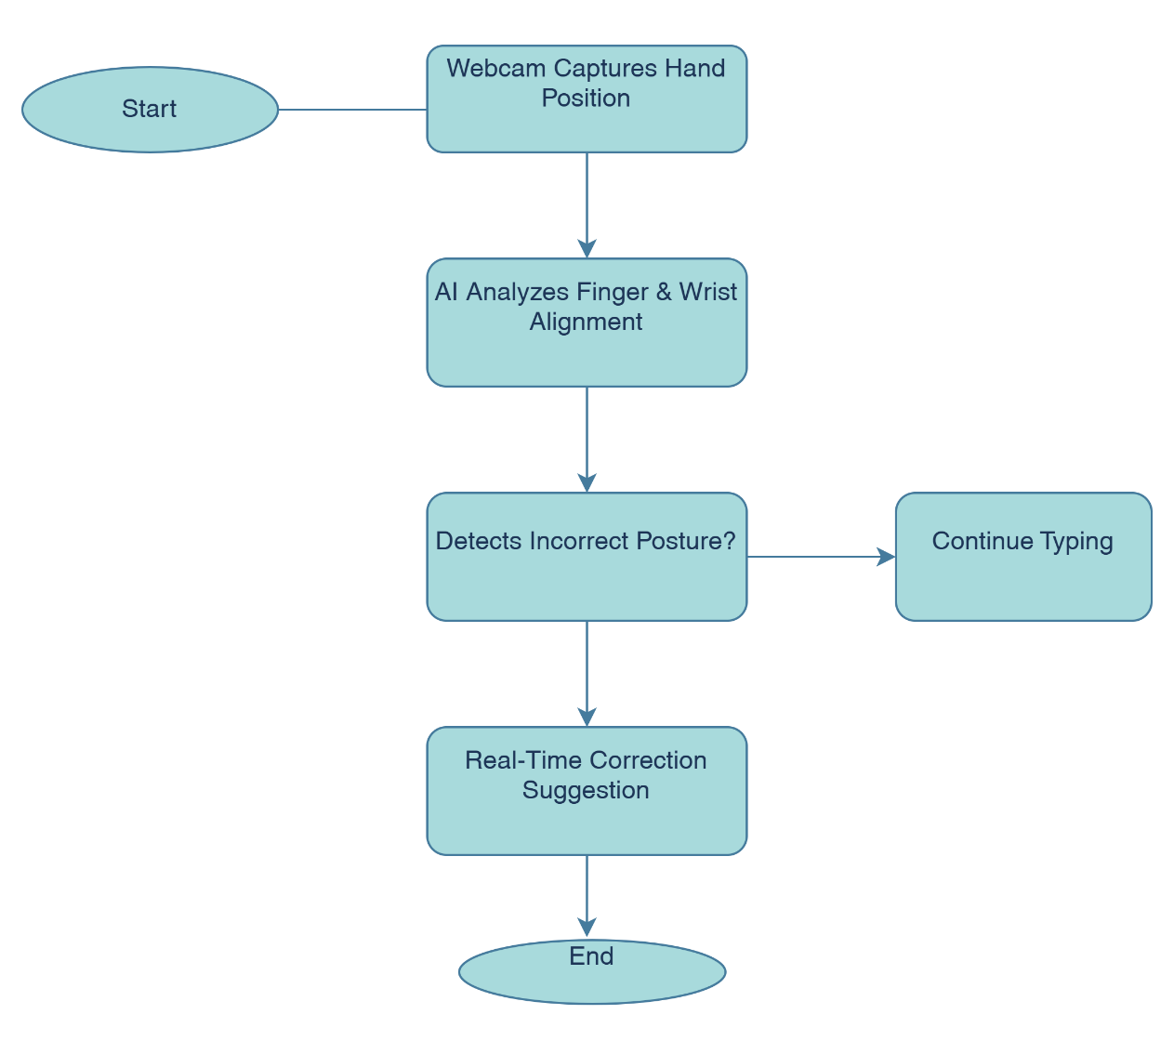
Figure 1: Overall System Workflow

Software Implementation

The software architecture of the typing tutor is built using a combination of machine learning frameworks, natural language processing algorithms, and computer vision techniques. The keystroke analysis and reinforcement learning models are developed using TensorFlow, PyTorch, or Scikit Learn, ensuring adaptive learning that personalizes exercises based on user performance. OpenCV and MediaPipe are used to implement real time hand tracking and ergonomic correction, analyzing hand placement and wrist angles via webcam input. The NLP module, responsible for generating user specific typing exercises, is powered by models such as SpaCy and GPT based AI, allowing contextual and topic specific practice sessions. The software is programmed in Python for backend AI processing, C++ for efficient real time execution, and JavaScript for seamless web based integration. Cloud storage solutions like Firebase or MongoDB are employed to store and sync user data across devices, ensuring accessibility and progress tracking.

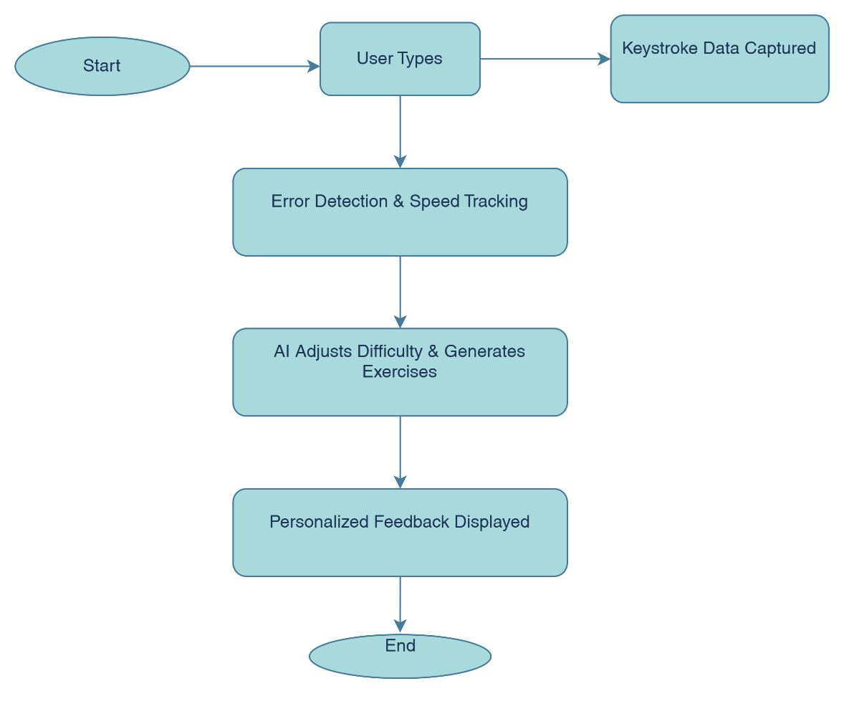
Figure 2: AI-Based Typing Analysis Flow

Functional Components and Workflow
1. Typing Analysis Engine
At the core of the system lies the typing analysis engine, responsible for monitoring keystroke dynamics, tracking typing speed, and identifying common mistakes. It continuously records user typing patterns, applies predictive analytics, and utilizes machine learning algorithms to detect inefficiencies. The system not only highlights frequent errors but also suggests targeted exercises to improve accuracy and speed. Reinforcement learning mechanisms further refine the tutor’s recommendations, ensuring continuous adaptation based on the user's performance trends. Unlike traditional typing tutors that follow a fixed syllabus, this AI powered engine dynamically evolves, creating a truly personalized learning experience.
2. Ergonomic Tracking System
To ensure healthy typing habits, the system integrates an ergonomic tracking module that utilizes computer vision for real time posture analysis. By analyzing wrist angles, hand positioning, and finger movements, the system provides instant corrective feedback to prevent strain injuries. Using deep learning based hand tracking models, the webcam continuously monitors the user’s hands, issuing alerts for incorrect posture or prolonged typing sessions. This feature is crucial for reducing the risk of repetitive strain injuries, making the system not just a learning tool but also a health focused application.
3. Natural Language Processing (NLP) Module
A major differentiator of this system is its NLP based exercise customization. Instead of generic typing drills, the AI dynamically generates lessons based on the user’s common vocabulary, writing style, and professional or academic needs. The system analyzes frequently used words, document samples, and messaging patterns to create personalized exercises that align with real world typing scenarios. This makes practice sessions more engaging and practical, improving both speed and context based typing accuracy.
4. AI Driven Gamification and Challenge System
To maintain motivation and engagement, the tutor incorporates a gamification system that introduces interactive challenges. The AI dynamically adjusts the difficulty level based on user progress, preventing frustration while maintaining a sense of achievement. Features like time bound speed challenges, accuracy based competitions, and error reduction tasks ensure continuous improvement. A leaderboard and reward system further encourage user participation by introducing friendly competition, making the typing experience enjoyable and goal oriented.
5. Emotion and Fatigue Detection System
A key innovation of the system is its ability to monitor the user’s emotional state and fatigue levels. By analyzing facial expressions through webcam input and detecting changes in keystroke patterns, the AI can recognize signs of frustration, hesitation, or mental fatigue. If a decline in motivation is detected, the system provides personalized encouragement through voice feedback or suggests taking a break. This ensures that users maintain a healthy learning pace without experiencing burnout.
6. Cross Platform Integration and Cloud Synchronization
To maximize accessibility, the typing tutor is designed to function across multiple devices, including desktops, tablets, and smartphones. A cloud based synchronization system ensures that users can seamlessly switch devices without losing progress. API integration also allows educational institutions and corporate environments to incorporate the tutor into existing training platforms, making it a scalable solution for large organizations.

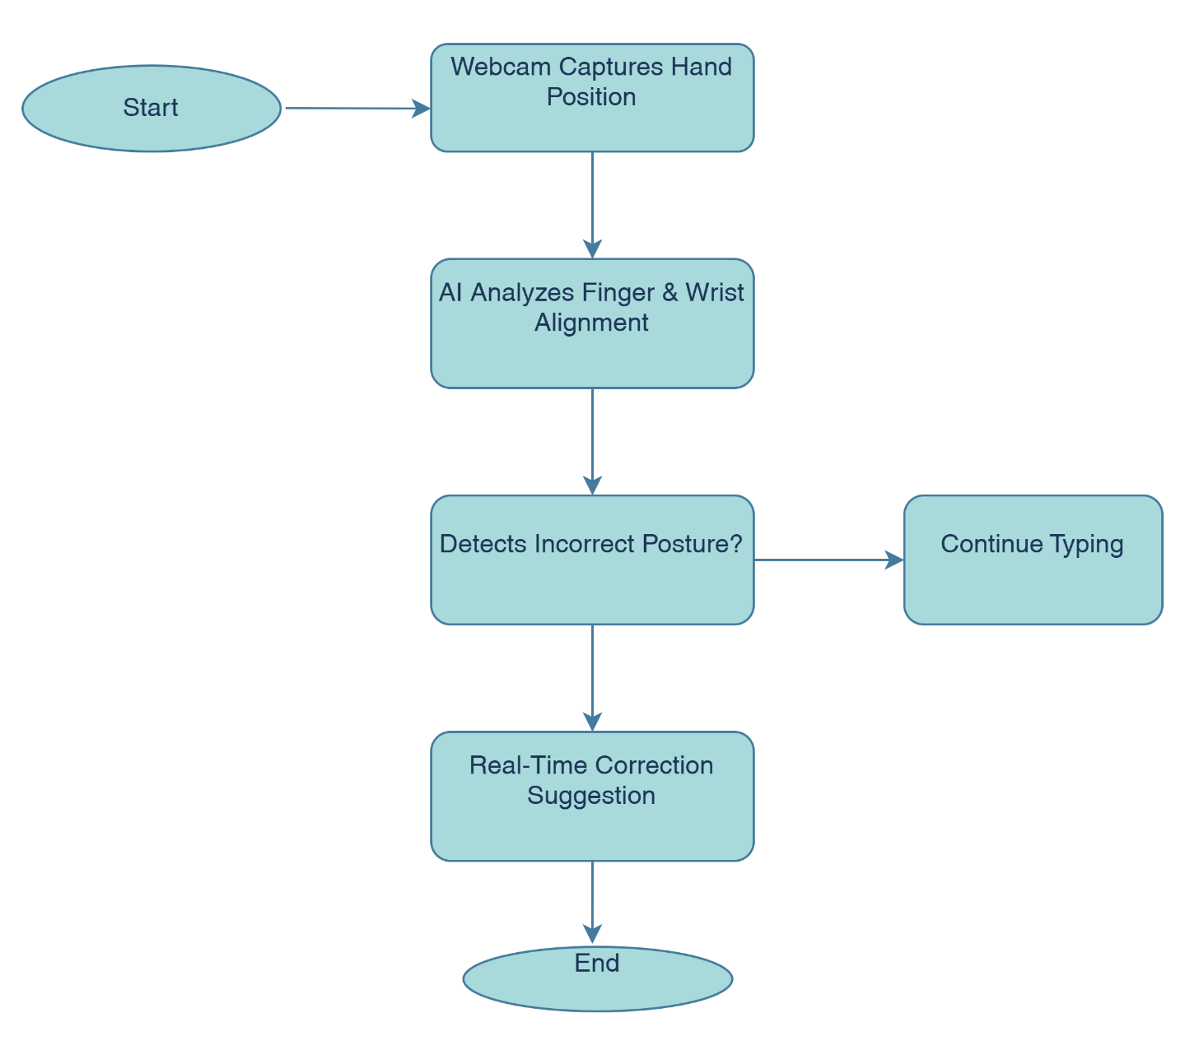
Figure 3: Posture Correction Flow (Computer Vision)

Overall System Workflow
1. User Initialization and Assessment
When a new user first interacts with the system, they undergo an initial typing assessment. The AI records their baseline typing speed, accuracy, and keystroke dynamics. Simultaneously, the ergonomic tracking system evaluates hand posture, wrist alignment, and finger movement. This assessment phase establishes a personalized training profile that guides the system’s recommendations.
2. Personalized Exercise Generation
Based on the assessment data, the NLP module generates customized exercises that align with the user’s skill level, professional field, and commonly used words. The AI also selects exercises designed to correct specific weaknesses detected in the assessment phase. For example, if the user frequently mistypes certain letter combinations, the system emphasizes those patterns in upcoming lessons.
3. Real Time Feedback and Adaptive Learning
During typing sessions, the system continuously analyzes keystrokes, posture, and typing patterns. Immediate feedback is provided for errors, incorrect hand positioning, or inefficient typing habits. The AI dynamically adjusts difficulty levels, ensuring that users remain challenged without feeling overwhelmed. Additionally, gamification features introduce competitive elements, rewarding users for progress while maintaining engagement.
4. Emotion and Fatigue Monitoring
As the user progresses, the emotion detection module tracks facial expressions and keystroke hesitation to determine levels of stress or fatigue. If signs of frustration or mental exhaustion are detected, the system offers encouragement, suggests taking a break, or adjusts the difficulty to reduce stress. This ensures a sustainable learning process that prioritizes both skill development and user well being.
5. Cloud Based Progress Tracking and Multi Device Access
All user data, including typing progress, ergonomic reports, and AI generated exercise history, is stored in the cloud. This allows seamless access from any device, ensuring that users can continue their training across multiple platforms. The integration of cloud computing also supports institutional deployments, allowing schools and businesses to track the progress of multiple users efficiently.

G. EXISTING DATA: NA

4. USE AND DISCLOSURE (IMPORTANT): Please answer the following questions:

- Have you described or shown your invention/ design to anyone or in any conference? | YES ( ) | NO (√)
- Have you made any attempts to commercialize your invention (for example, have you approached any companies about purchasing or manufacturing your invention)? | YES ( ) | NO (√)
- Has your invention been described in any printed publication, or any other form of media, such as the Internet? | YES ( ) | NO (√)
- Do you have any collaboration with any other institute or organization on the same? Provide name and other details. | YES ( ) | NO (√)
- Name of Regulatory body or any other approvals if required. | YES ( ) | NO (√)

5. Provide links and dates for such actions if the information has been made public (Google, research papers, YouTube videos, etc.) before sharing with us. NA

6. Provide the terms and conditions of the MOU also if the work is done in collaboration within or outside university (Any Industry, other Universities, or any other entity). NA

7. Potential Chances of Commercialization
The AI-powered adaptive typing tutor has significant commercialization potential due to its innovative features and the increasing demand for advanced typing software. Its competitive advantage lies in unique capabilities such as real-time ergonomic feedback, AI-powered gamification, and emotional support, which set it apart from conventional typing tutors. The system is highly adaptable and can integrate seamlessly with existing keyboards and educational platforms, making it accessible to a broad range of users. The target market includes professionals, such as programmers and writers, who rely on efficient typing skills, as well as students seeking to improve their typing speed and accuracy. Additionally, incorporating accessibility features for users with disabilities enhances inclusivity and broadens market reach. The marketing strategy focuses on digital marketing through online platforms and social media to showcase the system’s unique benefits, along with partnerships with educational institutions and professional organizations to drive adoption. The revenue model includes a subscription-based service that offers premium features, regular updates, and personalized support, as well as licensing opportunities for other educational software companies to integrate AI-powered typing enhancements into their platforms.

8. List of Companies for Potential Commercialization:
To commercialize the AI-Powered Adaptive Typing Tutor, consider reaching out to the following companies specializing in typing software and AI-based educational tools:
- Ambow Education Holding Ltd.
  - Description: Ambow is a global education company providing educational software and hardware for hybrid online and offline learning, including platforms with AI translation and content creation.
  - Website: http://www.ambow.com
- Tata ClassEdge
  - Description: Tata ClassEdge offers digital education solutions for schools and colleges in India, providing software, hardware, and books to support digital classroom experiences.
  - Website: https://www.tataclassedge.com
- MagicSchool
  - Description: MagicSchool is a technology platform that provides various AI tools to assist teachers with their diverse tasks, enhancing the educational experience.
  - Website: https://www.magicschool.ai

9. Any basic patent which has been used and we need to pay royalty to them. NA

10. FILING OPTIONS: Please indicate the level of your work which can be considered for provisional/ complete/ PCT filings (complete).

11. KEYWORDS:
- AI-Powered Typing Tools
- Hand and Finger Tracking Technology
- Computer Vision for Typing Analysis
- Real-Time Ergonomics Feedback
- AI-Driven Typing Exercises
- Personalized Typing Practice
- Natural Language Processing (NLP) in Typing
- AI-Powered Gamification for Typing
- Emotion Detection in Typing Software
- AI-Based Typing Habit Analysis
- Machine Learning for Typing Efficiency
- Intelligent Typing Assistants
- AI-Enhanced Keyboard Interaction
- Adaptive Typing Systems
- Smart Typing Software

